What is Apache Avro?
Apache Avro is a data serialization framework developed under the Apache Software Foundation.
It is mainly used for:
- Efficient data storage
- Fast data serialization
- Schema evolution
- Big Data processing pipelines
It is commonly used with:
- Apache Kafka
- Apache Spark
- Apache Hadoop
- Apache Flink

Why Avro is Important in Data Engineering?
Compact & Fast
- Data stored in binary format
- Smaller size than JSON or XML
- Faster serialization/deserialization
Schema-Based
- Uses JSON to define schema
- Ensures strong data structure validation
Schema Evolution Support
- You can:
  - Add new fields
  - Remove fields
  - Provide default values
Without breaking old consumers
Language Independent
Supports:
- Java
- Python
- Scala
- C++
- Go
- .NET

Avro Architecture
Avro contains:
- Schema → Defines structure (JSON format)
- Data → Stored in binary format
- Serialization / Deserialization

Example Avro Schema
{
"type": "record",
"name": "Employee",
"namespace": "com.data.engineering",
"fields": [
{"name": "id", "type": "int"},
{"name": "name", "type": "string"},
{"name": "salary", "type": "double"},
{"name": "department", "type": "string"}
]
}
This schema defines:
- id → integer
- name → string
- salary → double
- department → string

Avro vs JSON
Feature | Avro | JSON
Storage | Binary | Text
Size | Smaller | Larger
Speed | Faster | Slower
Schema | Required | Not required
Schema Evolution | Yes | Difficult

Real-Time Use Case (Kafka + Avro)
Scenario:
You are building a real-time banking transaction system.
- Producer sends transaction data in Avro format
- Schema stored in Schema Registry
- Consumer reads data using same schema
- If schema changes → backward compatible
This is common in:
- Payment systems
- E-commerce
- Healthcare analytics
- IoT pipelines

Avro in Data Engineering Pipeline
Example pipeline:
Data Source → Kafka (Avro) → Spark → Data Lake (HDFS/S3) → BI Tool
- Kafka uses Avro for compact streaming
- Spark reads Avro files for processing
- Data Lake stores Avro files efficiently

Avro File Format
An Avro file contains:
- Header
  - Schema
  - Metadata
- Data blocks
  - Binary records

Interview Questions (Data Engineering)
Basic
- What is Apache Avro?
- Why Avro is preferred in Kafka?
- Difference between Avro and JSON?
Intermediate
- What is schema evolution?
- What is backward compatibility in Avro?
- How does Avro store schema?
Advanced
- Explain Avro with Kafka Schema Registry.
- How does Avro improve performance in big data systems?
- Compare Avro vs Parquet vs ORC.

Avro vs Parquet (Quick Overview)
Feature | Avro | Parquet
Format Type | Row-based | Column-based
Best For | Streaming | Analytics
Kafka Use | Yes | No
Spark Use | Yes | Yes
Use Avro for streaming
Use Parquet for analytics queries

When to Use Avro?
Real-time streaming
Kafka messaging
Schema evolution required
Microservices communication
Compact binary storage

Step 1: Install Docker
Make sure Docker is installed:
docker --version
docker compose version
If not installed:
Install Docker Desktop (Windows/Mac)
On Linux: sudo apt install docker.io

Step 2: Create Project Folder
mkdir kafka-avro-demo
cd kafka-avro-demo

Step 3: Create docker-compose.yml
Create file:
touch docker-compose.yml
Paste this:

services:
zookeeper:
image: confluentinc/cp-zookeeper:7.5.1
container_name: zookeeper
hostname: zookeeper
ports:
- "2181:2181"
environment:
ZOOKEEPER_CLIENT_PORT: 2181
ZOOKEEPER_TICK_TIME: 2000
restart: always
volumes:
- zk-data:/var/lib/zookeeper/data
- zk-log:/var/lib/zookeeper/log

kafka:
image: confluentinc/cp-kafka:7.5.1
container_name: kafka
hostname: kafka
depends_on:
- zookeeper
ports:
- "9092:9092"
restart: always
environment:
KAFKA_BROKER_ID: 1
KAFKA_ZOOKEEPER_CONNECT: zookeeper:2181

# Listeners
KAFKA_LISTENERS: INTERNAL://0.0.0.0:29092,EXTERNAL://0.0.0.0:9092
KAFKA_ADVERTISED_LISTENERS: INTERNAL://kafka:29092,EXTERNAL://localhost:9092
KAFKA_LISTENER_SECURITY_PROTOCOL_MAP: INTERNAL:PLAINTEXT,EXTERNAL:PLAINTEXT
KAFKA_INTER_BROKER_LISTENER_NAME: INTERNAL

# Single broker setup
KAFKA_OFFSETS_TOPIC_REPLICATION_FACTOR: 1
KAFKA_TRANSACTION_STATE_LOG_REPLICATION_FACTOR: 1
KAFKA_TRANSACTION_STATE_LOG_MIN_ISR: 1

KAFKA_AUTO_CREATE_TOPICS_ENABLE: "true"

volumes:
- kafka-data:/var/lib/kafka/data

schema-registry:
image: confluentinc/cp-schema-registry:7.5.1
container_name: schema-registry
hostname: schema-registry
depends_on:
- kafka
ports:
- "8081:8081"
restart: always
environment:
SCHEMA_REGISTRY_HOST_NAME: schema-registry
SCHEMA_REGISTRY_LISTENERS: http://0.0.0.0:8081

# IMPORTANT FIX (NO INTERNAL://)
SCHEMA_REGISTRY_KAFKASTORE_BOOTSTRAP_SERVERS: kafka:29092

kafka-ui:
image: provectuslabs/kafka-ui:latest
container_name: kafka-ui
depends_on:
- kafka
- schema-registry
ports:
- "8080:8080"
restart: always
environment:
KAFKA_CLUSTERS_0_NAME: local
KAFKA_CLUSTERS_0_BOOTSTRAPSERVERS: kafka:29092
KAFKA_CLUSTERS_0_SCHEMAREGISTRY: http://schema-registry:8081
KAFKA_CLUSTERS_0_ZOOKEEPER: zookeeper:2181

volumes:
kafka-data:
zk-data:
zk-log:

Step 4: Start Kafka Cluster
docker compose up -d

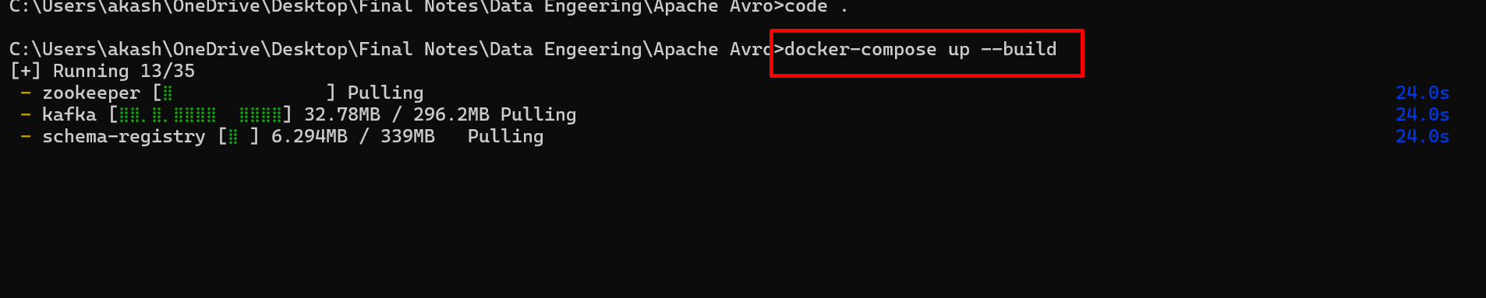

What this does
- Lists all running Docker containers
- Confirms that Kafka ecosystem services started correctly
You should see
zookeeper
kafka
schema-registry
kafka-ui (optional)

Why this step is important
- Kafka cannot work without Zookeeper
- Schema Registry must connect to Kafka
- If any container is missing → next steps will fail

To check all containers running or not
docker ps
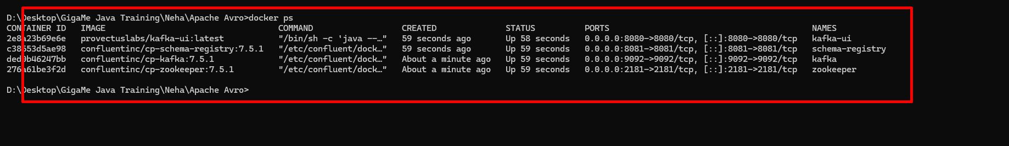

STEP 4: Create Kafka Topic
Now using below command we need to connect Kafka container os machine

docker exec -it kafka bash

kafka-topics --create --topic employee-topic --bootstrap-server localhost:9092 --partitions 1 --replication-factor 1

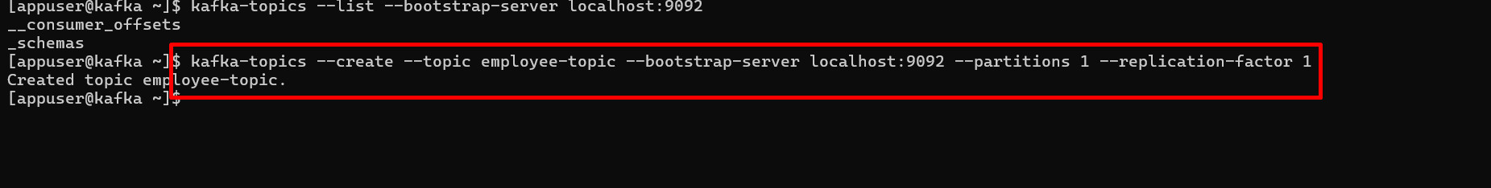

Verify:

kafka-topics --list --bootstrap-server localhost:9092

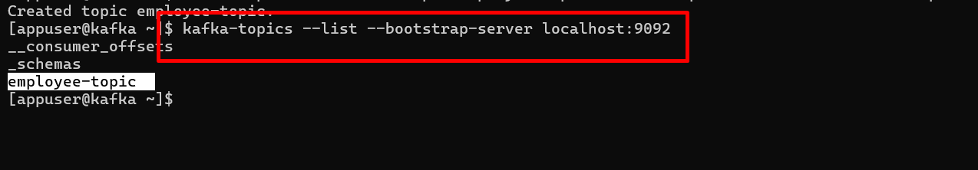
Exit:

You can check Kakfa Dashboard using below URL
http://localhost:8080

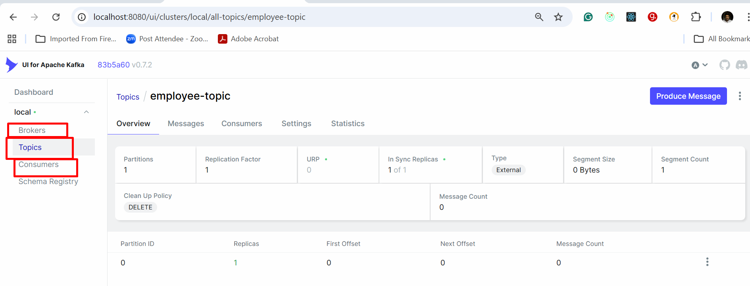

STEP 6: Enter Schema Registry Container

docker exec -it schema-registry bash

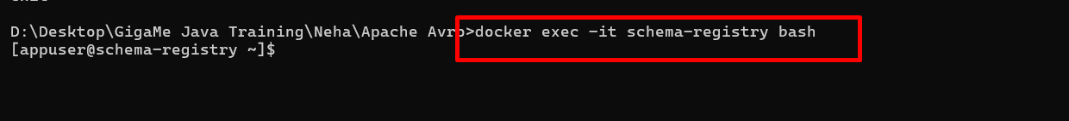

Create Avro Schema File
Below command create the file
touch employee.avsc

adding the contents inside that file

cat <<EOF > employee.avsc
{
"type": "record",
"name": "Employee",
"namespace": "com.demo",
"fields": [
{"name": "id", "type": "int"},
{"name": "name", "type": "string"},
{"name": "salary", "type": "double"},
{"name": "department", "type": "string"}
]
}
EOF

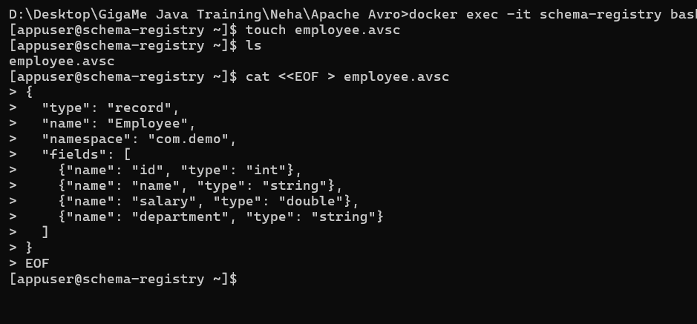

Produce Avro Message (NO EOF ERROR)
printf '{"id":1,"name":"Akash","salary":50000,"department":"IT"}\n' | \
kafka-avro-console-producer \
--broker-list kafka:29092 \
--topic employee-topic \
--property schema.registry.url=http://schema-registry:8081 \
--property value.schema='{
"type":"record",
"name":"Employee",
"namespace":"com.demo",
"fields":[
{"name":"id","type":"int"},
{"name":"name","type":"string"},
{"name":"salary","type":"double"},
{"name":"department","type":"string"}
]
}'

Produce Multiple Messages
printf '{"id":”abc”,"name":"Ravi","salary":60000,"department":"HR"}\n{"id":”xyz”,"name":"Neha","salary":70000,"department":"Finance"}\n' | \
kafka-avro-console-producer \
--broker-list kafka:29092 \
--topic employee-topic \
--property schema.registry.url=http://schema-registry:8081 \
--property value.schema='{
"type":"record",
"name":"Employee",
"namespace":"com.demo",
"fields":[
{"name":"id","type":"int"},
{"name":"name","type":"string"},
{"name":"salary","type":"double"},
{"name":"department","type":"string"}
]
}'

Consume Avro Messages
kafka-avro-console-consumer \
--bootstrap-server kafka:29092 \
--topic employee-topic \
--from-beginning \
--property schema.registry.url=http://schema-registry:8081

Expected Output:
{"id":1,"name":"Akash","salary":50000,"department":"IT"}
{"id":2,"name":"Ravi","salary":60000,"department":"HR"}
{"id":3,"name":"Neha","salary":70000,"department":"Finance"}

Verify Schema Registry
Open browser:
http://localhost:8081/subjects

["employee-topic-value"]

Verify Apache Kafka

http://localhost:8080/

Stop Everything
Stop containers
docker compose down
Stop + remove volumes
docker compose down -v

Real Data Engineering Use Case
Production Architecture
Microservice → Kafka (Avro) → Spark Streaming → Data Lake → BI
Used in
- Banking transactions
- E-commerce orders
- Healthcare pipelines
- IoT real-time analytics

